A Study on the Performance and Interference Mitigation of Wi-Fi 6 & 7 Technologies
Johans Cipriano∗, Ford Chung†, Shanley Valenzuela‡,
∗†‡College of Computer Studies, De La Salle University, Manila, Philippines
Email: {ford chung∗, johans cipriano†, shanley valenzuela‡}@dlsu.edu.ph;

Abstract
Abstract— This study tackles the latest advancements of Wi-Fi technologies, Wi-Fi 6 and Wi-Fi 7. By comparing these newer technologies with previous generations, this research assesses key improvements and features that help mitigate challenges in connectivity and interference. Methods such as BSS Coloring, Orthogonal Frequency Division Multiple Access (OFDMA), and Multi-User Multiple Input Multiple Output (MU-MIMO) for Wi-Fi 6 to address network congestion. Wi-Fi 7 introduces additional features, such as Multi-link operation and Multi-AP Cooperation, which aims to provide greater speeds. The study aims to discern whether new Wi-Fi technologies has significantly improved over prior Wi-Fi generations through various comparative analysis.
Keywords—Wi-Fi 6, Wi-Fi 7, Interference Mitigation

Introduction
The rapid evolution of Wi-Fi technology has transformed wireless networking. Its advancements met the increasing demands of today’s digitally connected world. With the introduction of Wi-Fi 6 (802.11ax) and the latest Wi-Fi 7 (802.11be) which was introduced earlier just this year, it shows how the industry has reached new heights in regards to performance and efficiency over the past few decades. Wi-Fi 6, which was launched in 2019, was designed to alleviate the challenges that are currently being faced in crowded environments. Dense places like cities which tend to have multiple devices or networks sharing the frequency spectrum, have a hard time due to overcrowding, interference, and limited bandwidth.
There is also Wi-Fi 7, the newest and next step in wireless networking. Introduced in early January of 2024, its features such as Multi-Link Operation (MLO) and 4k QAM modulation, Wi-Fi 7 is expected to achieve speeds up to 30 Gbps, making it an even more powerful network that will help meet the demands of modern devices [1]. Despite these advancements, the issue of interference is still a big deal in the evolution of Wi-Fi technologies.
As more and more people demand for wireless connectivity, and with more devices relying on Wi-Fi for everything from simple browsing to online gaming, the problem of interference is highly likely to happen more frequently. These environments include office buildings, stadiums, airports, and apartment buildings. Which is why having methods and techniques to help mitigate interference are very important in these kinds of conditions where multiple networks and devices are competing for limited spectrum space. This paper explores the development of Wi-Fi technologies through Wi-Fi 6 and Wi-Fi 7. By comparing it and knowing how it faces challenges faced by past generations, this study will help understand what makes it different and how Wi-Fi technology continues to evolve and adapt to the needs of today’s world [1]. Additionally, this paper will provide key methods that help mitigate interference in dense environments. By drawing from existing research papers such as Wi-Fi Evolution: Beyond Wi-Fi 6 by Balkonis Mikhail, it will explore these, providing insights on how it shapes the future of wireless connectivity.

RRL

Wi-Fi 6
Wi-Fi 6, also known as 802.11ax, was designed as a response to address the challenges that were observed when IEEE and Wi-Fi Alliance had a survey regarding Wi-Fi [1]. It was said that due to an increase in connected devices and high traffic in an area, there was low data rate due to interference. The purpose of Wi-Fi 6 was to enhance the overall efficiency and reliability of wireless networks in crowded places like apartment buildings, public spaces, airports, schools and many more. While previous generations such as Wi-Fi 5, also known as 802.11ac, focused on improving peak data rates, Wi-Fi 6 shifts its focus on improving the minimum and average performance it can provide when there are countless numbers of devices.
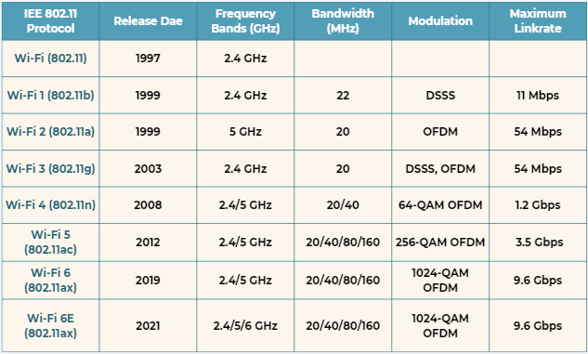
Figure 1: Wi-Fi Technologies Comparison [1]
Wi-Fi 6 was definitely a huge upgrade over previous generations like Wi-Fi 4 and Wi-Fi 5. It is faster in terms of speed, efficiency, and has improved its performance, especially when numerous devices are connected in the same area. Wi-Fi 6 can reach up to speeds of 9.6 Gbps, which is about 36% faster than Wi-Fi 5’s top speed of 6.9 Gbps [1]. And Wi-Fi 5’s max speed can only be achieved with ideal conditions, so in normal conditions, its top speed goes down to 3.5 Gbps. This was possible by implementing 1024-QAM instead of 256-QAM, which increases the maximum rates by 1.25 times. Additionally, Wi-Fi 6 supports both 2.4 GHz and 5 GHz Frequency Bands for data transmission, and even 6 GHz frequency band in Wi-Fi 6E which provides better throughput than previous generations. Wi-Fi 5 does use both 2.4 and 5 GHz Frequency Bands as well, however Wi-Fi 5 tends to focus more on using 5 GHz, where 2.4 GHz band is often limited to older devices.
With Wi-Fi 6 and Wi-Fi 6E being significantly better than previous generations, how did it improve so much? It improved due to its ability to handle multiple devices simultaneously without experiencing any problems in terms of speed. This was done with new and improved features such as OFDMA, MU-MIMO, and BSS Coloring.

OFDMA
OFDMA, also known as Orthogonal Frequency Division Multiple Access is a method used for better usage of transmitting and receiving data. It is the successor of OFDM (Orthogonal Division Frequency Multiplexing) which was used in previous generations. In OFDM, depending on the channel’s width and number of devices in use, it will use x number of channels for x number of devices per time segment. In other words, at a given moment, if there are multiple devices trying to transmit or receive data at the same time, a channel can only support one data packet for a user at a time. This was an issue in the past since it is inefficient in usage of channels, especially when data packets being sent or received are small. OFDMA fixes that issue by subdividing channels into smaller resource units. And these sub-sections will be allocated among multiple devices, making it more efficient and maximizing the potential of the channels.

MU-MIMO
Wi-Fi 6 has also improved MU-MIMO (Multi-User, multiple input, multiple output). MU-MIMO was first introduced in Wi-Fi 5, where its purpose is to help routers simultaneously connect with multiple devices. This is done by using spatial multiplexing with independent data streams on the same bandwidth [1]. Spatial Multiplexing is a method that allows multiple data streams to occur over the same frequency band. Similar to what happens in OFDMA, the data streams are allocated in spatial channels, which makes multiple data packets to be sent at the same time. In Wi-Fi 5, downlink MU-MIMO was shown for the first time, where the AP (access point) transmits data to up to 4 devices at the same time. However in Wi-Fi 6, it has improved to 8 devices. It has also introduced uplink MU-MIMO, where devices can also send back to the AP, increasing overall efficiency in the network.

BSS Coloring
In densely populated areas, it is normal for Wi-Fi networks to operate on the same channels. This could turn into a problem which can lower overall efficiency and network performance. And that is where BSS Coloring comes in, in the name itself, it adds a color code to each Basic Service Set (BSS) which will distinguish between networks operating on the same channel. By having different color assignments, it will help determine whether incoming signals are part of the network (same color) or belongs to a neighboring network (different color).
Throughout this RRL, the launch of Wi-Fi 6 was described as a breakthrough in Wi-Fi Technologies where problems in dense environments were mitigated. Despite these advancements, Wi-Fi 6 is still not yet perfect. Wi-Fi 6 is still dependent on the current devices such as phones, laptops, and routers. This is the case since there are still devices that are not compatible with Wi-Fi 6, which means that Wi-Fi 6 is redundant if no devices use it. It takes time for new devices with compatibility to be launched. And high congestion can still be an issue. Even though Wi-Fi 6 was designed to help solve the problem, there are still limitations on how much it can handle in crowded spaces such as offices, malls, schools, and many more.

Wi-Fi 7
Wi-Fi 7, also known as IEEE 802.11be, was created to satisfy the high demands of emerging technologies such as 4k/8k video, augmented reality, and virtual reality (VR), which require high throughput and low latency. Wi-Fi 7 supports an extremely high throughput of at least 30Gbps, four times faster than Wi-Fi 6. This can be achieved by increasing the channel width to 320MHz, resulting in more data being passed with each transmission. Due to the huge jump of speed, it introduced challenges to current device’s hardware and the need to update it to support Wi-Fi [2]. It also ensures that it will still be compatible with legacy devices in the 2.4, 5, and 6 GHz unlicensed bands [1]. Wi-Fi 7 would likely be used in places that require high speed like airports, schools, hospitals, etc. To achieve the speed required for Wi-Fi 7, multiple technologies on PHY and MAC have been discovered and enhanced.
Multiple enhancements have been made to the MAC layer of Wi-Fi 7 compared to the older technologies that increase its performance and reliability. These include the Multi-Link Operation, MIMO, Multi-AP coordination and HARQ.

Multi-Link Operation
Multi-link operation (MLO) is a valuable feature for Wi-Fi 7 giving it the ability to simultaneously transmit data across different frequency bands, unlike the older versions of the Wi-Fi technology. This will result in an overall increase in throughput and minimizing latency. An analysis was done by Jeknić and Kočan (2024) [3] using ns-3 to simulate the efficiency of the multi-link operation in indoor scenarios. The results show that there is a 92.5% throughput improvement from Single Link Operation (SLO) to a two-links MLO for an 80MHz link and an 84.3% improvement for the 160 MHz links. The analysis also shows that there is a 2.66 times delay decrease from MLO compared to the SLO when traffic increases. This study shows that there are great improvements in speed and latency from utilizing MLO.
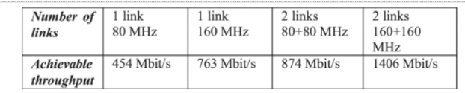
Figure 2: Analysis on different link configuration throughput [3]

MIMO
Wi-Fi 7 aims to double the number of spatial streams from the previous 8 spatial streams of Wi-Fi 6 to 16 spatial streams which result in 16 antennas [1]. An increase in the spatial streams will provide better spatial multiplexing capabilities and it can serve up to 16 users for uplink/downlink transmissions [2].

Multi-AP coordination
EHT capabilities allow sharing of data and control information among acc ess point devices using physical or wireless links, increasing overall efficiency. This multi-AP coordination was an improvement from the Wi-Fi 6 which only uses a single AP and reuse of STA’s which limits its performance. Multi-AP coordination is divided into multiple types depending on a scenario, this includes, coordinated spatial reuse (CSR), coordinated orthogonal frequency-division multiple access (C-OFDMA), coordinated beamforming (CBF), and joint transmission (JXT) according to different coordination complexity.

HARQ
Hybrid automatic repeat request (HARQ) is a method to enhance error detection and retransmission. It stores the incorrect information and combines it with other retransmitted units to increase the probability of correct decoding. HARQ is an improvement to automatic repeat requests (ARQ) which drops the incorrectly decoded packets rather than storing them.

Moreover, physical layer enhancement was also done to support the needs of Wi-Fi 7. Wi-Fi 7 offers a much larger throughput of at least 30 Gbps with the usage of a 320 MHz channel. This 320 MHz channel can either be continuous within the same 6 GHz band or split into non-continuous segments across different bands. This is shown in the figure below. A redesign to the EHT preamble was also done to ensure that older Wi-Fi standards will still be compatible with Wi-Fi 7, by introducing flexible fields and preamble puncturing. Preamble puncturing is a method that allows the merging of multiple channels in a non-continuous way. And lastly, the introduction of 4096-QAM. It is an improvement to the 1024-QAM of Wi-Fi 6 increasing the number of bits a modulated symbol can carry from 10 to 12, resulting in an increase of 20% in data rate [1].
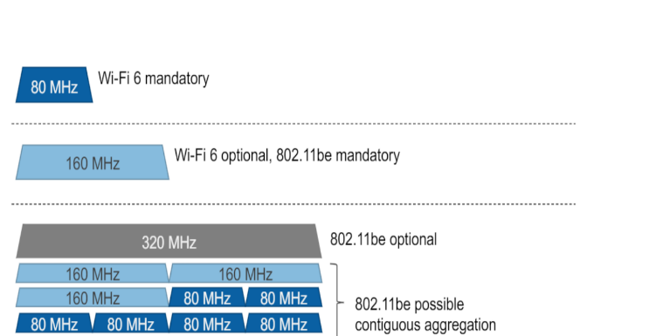
Figure 3: Channel Splitting Types [1]
Given the data received of comparison throughout each feature, the researchers can conclude that Wi-Fi 7 has improved their speed and reliability compared to Wi-Fi 6. Wi-Fi 7 doubled their band from 160 MHz to 320 MHz and added a multi-link operation to utilize multiple bands while drastically improving its speed of up to 84.3%. Additionally, data rate has been increased by four times from 9.6 Gbps to at least 30 Gbps, with the help of the modulation that increased its data rate to 20% compared to Wi-Fi 6. Limitation of Wi-Fi 7 also includes backward compatibility to different Wi-Fi technology, hardware upgrades to accommodate the need of Wi-Fi 7 to increase its throughput and efficiency [4].

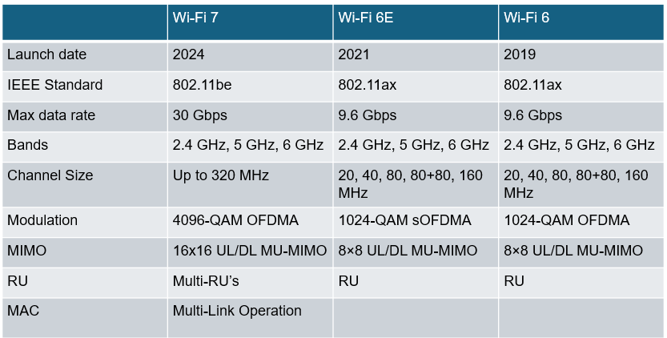
Figure 4: Comparison of Features between Wi-Fi 6, 6E and 7

Evolution to Wi-Fi 7
As previously mentioned, Wi-Fi 7 addresses the need of real-time applications like VR and AR for networks that provide extremely high throughput with low latency and jitter. Wi-Fi 7 targets ultra-high definition video traffic and real-time traffic with the main objective of achieving extremely high throughput (at least 30Gbps).

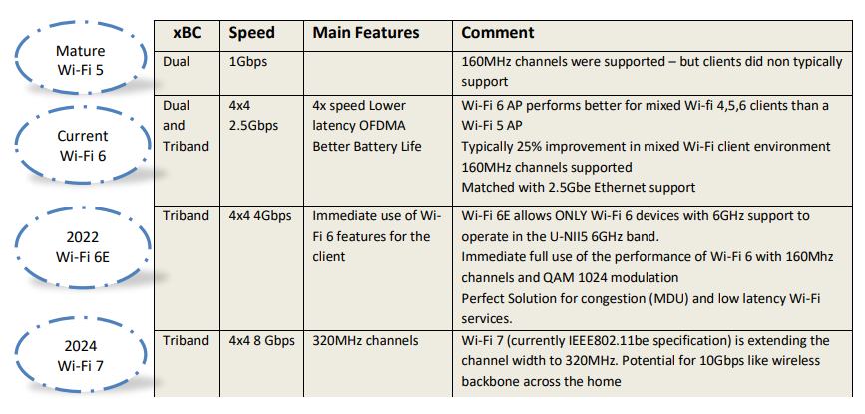
Figure 5: Evolution of Wi-Fi [1]
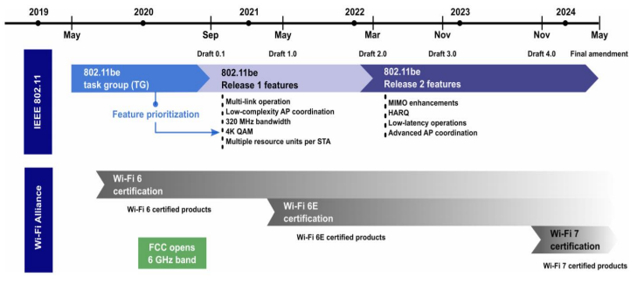
Figure 6: Development Timeline of Wi-fi 7 [1]
The figures above show the evolution of Wi-fi from 5 to 7 and the development timeline of Wi-Fi 7 according to the 802.11be Task Group (TG). The process involved two phases, the first of which targetted “high-priority” features like multi-link operation, low-complexity AP coordination, 320 MHz bandwidth, 4K QAM, and multiple resource units per STA. Phase 2 provided additional features of lower priority such as MIMO enhancements, HARQ, low-latency operations and advanced AP coordination. PHY layer enhancements were performed in Phase 1 while multi-band operation, AP coordination, enhanced link reliability, latency and jitter guarantee, and other technologies were promised by Phase 2.
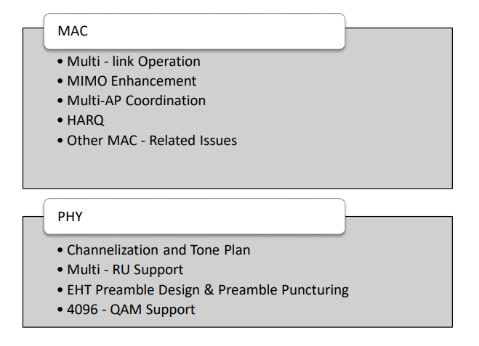
Figure 7: PHY & MAC Layer Features of Wi-Fi 7 [1]

Interference Mitigation
Various interference mitigation techniques have been explored by different authors. For this review, the researchers will categorize them based on the layer where the technology is applied.

Physical Layer (PHY)
- Orthogonal Frequency Division Multiplexing (OFDM)
- Channel Allocation and Power Control
- Error Correction
- Beamforming

Medium Access Control Layer (MAC)
- Carrier Sense Multiple Access with Collision Avoidance (CSMA/CA)
- Request to Send / Clear to Send (RTS/CTS)
- BSS Coloring
- Spatial Reuse
- Time-Sensitive Networking
OFDM ensures minimal interference between frequencies by dividing a signal into multiple orthogonal subcarriers. According to [5] , wavelet-based OFDM system outperforms Fourier-based OFDM in many cases. Both systems were applied to digital video broadcasting – terrestrial system with impulsive noise interference.
As seen in Figure 8, the inverse discrete Fourier transform (IDFT) and Discrete Fourier Transform (DFT) are used to modulate and demodulate the low-rate data symbols on an orthogonal subcarrier [6].
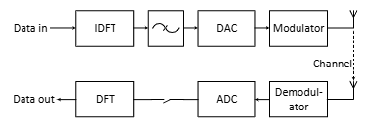

Figure 8: Simplified scheme of an OFDM transceiver [6]
As the data points travel on the subcarrier, symbols are mapped using PSK, QAM, or other digital modulation schemes.
The same paper says OFDM can easily be extended to MIMO systems to increase transmission capacity. By doing so, [6] claims that OFDM-based systems can achieve transmission rates several magnitudes higher than those of current mainstream technologies.
Channel Allocation and Power Control minimizes interference in overlapping networks by (1) dynamically selecting less congested channels and (2) adjusting transmission power. Some IoT protocols that attempt to increase range while reducing transmission power include Sigfox, Ingenu, and LoRaWAN [7]. These protocols use unique techniques to meet the standard of Wi-Fi 6. However, long-range transmission with other wireless technologies (Bluetooth, microwave, 2.4 GHz devices) is still heavily affected by the outdoor environment.
In 2019, [8] attempted to produce an optimal algorithm for this technology for D2D users (shown in Figure 9).
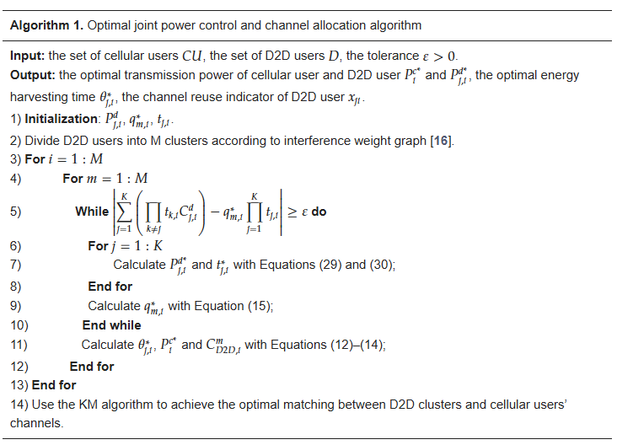
Figure 9: An Optimized Algorithm for Joint Channel Allocation and Power Control
The algorithm consists of three steps: (1) clustering N D2D users into M clusters in N-M iterations, (2) allocating power to D2D users, and (3) matching channels between D2D clusters and cellular users. Results showed that this algorithm performed the best and the authors sought energy harvesting mechanisms as the next step to improving this technology.
One common effect of Wi-Fi interference other than slow transmission is the loss of data. Erratic transmission is observed in video transmission over 2.4 GHz wireless channels. To address this, [9] introduced a model using Forward Error Correction (FEC) mechanisms to monitor MP4 video streaming. FEC are widely employed in Wi-Fi systems to improve data recovery in noisy environments, minimizing data errors and losses.
To simulate this, [9] used a neuro-fuzzy technique for video transmission where each frame is subjected to spatial compression, dynamically adjusting the bitrate based on available resources. They observed that video quality improves as the FEC overhead increases. This is because higher FEC overhead implies a more successful decoding.
Another cause of slow connectivity is the bandwidth-sharing when a wireless signal is broadcasted uniformly. Fortunately, Wi-Fi 5-7 incorporates Beamforming, a technique that focuses a signal on specific devices in lieu of broadcasting. This approach reduces interference with neighboring devices.
Studies on this technology date back as early as 2013 around the time it was introduced as part of IEEE 802.11ac (WiFi 5) [10]. It used to rely on simple algorithms like the Least Mean Square algorithm (LMS) to optimize beamforming patterns. However, by 2020, beamforming started [11].
CSMA/CA is WiFi's primary method for avoiding collisions during data transmission. Before transmitting, devices sense the medium to ensure it is free. If the medium is busy, devices back off for a random period before retrying. [12] says that CSMA/CA's reduces collisions and manages interference in shared environments, particularly those with overlapping networks.
RTS/CTS protocols reserve the channel for specific transmissions to prevent interference from hidden nodes—devices that cannot directly detect each other's transmissions.
This mechanism is effective in dense networks with multiple overlapping devices, so transmissions are not disrupted by hidden node interference.
BSS Coloring, introduced in WiFi 6, allows overlapping networks to reuse the same frequency channels by marking packets with unique identifiers. [13] details that this feature reduces contention and improves efficiency in environments with multiple access points operating in close proximity.
Spatial reuse improves spectrum efficiency by allowing devices in separate physical areas to use the same frequency channels without interfering. [12] discussed how this technique maximizes spectrum utilization and throughput, especially in crowded settings like offices and apartments.
WiFi incorporates time-sensitive protocols to allocate transmission slots fairly to avoid simultaneous transmissions that can cause interference. These protocols are essential for applications requiring low latency, such as video conferencing, gaming, and real-time IoT operations. By prioritizing time-critical data, WiFi ensures a consistent user experience even in busy networks [1].

,METHODOLOGY (Discussion of ChatGPT Results vs Your Research)
In this section, the researchers compare the results provided by ChatGPT, a popular AI language model. The aim of this section is to assess ChatGPT’s response on whether it is accurate and relevant to this research study.

The first prompt given to ChatGPT was, “Explain everything about Wi-Fi 6, its comparison with past generations, and its improvements in detail” for Wi-Fi 6. When comparing the AI generated review regarding Wi-Fi 6 with the primary research findings, there were some similarities, particularly in the features and its improvements. However, the AI responses sometimes lacked in depth and only provided general info regarding the features. For instance, ChatGPT provided a broad explanation and the impact of each feature Wi-Fi 6 has. Although it helps give a good understanding of how each feature works, it does not go into detail which is needed in a study like this.
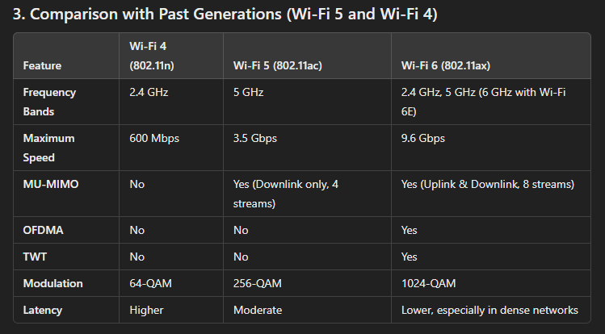
Figure : ChatGPT generated Table
It also provided a comparison between Wi-Fi 4, 5, and 6 for better understanding of what the improvements were over the years. One key problem observed was in the Maximum Speed for Wi-Fi 5. Although it is technically correct that in normal conditions, the maximum link rate is 3.5 Gbps, in ideal conditions, it can reach up to speeds of around 6.9 Gbps [9].

The second prompt, “Explain Wi-Fi 7 and its well-known features and specifications, and compare it to Wi-Fi 6”, focuses on Wi-Fi 7 and its comparison to Wi-Fi 6. ChatGPT provided a good comparison on the general function of both Wi-Fi 6 and 7, for its introduction, emphasizing speed and reliability of Wi-Fi 7 and its uses. It then proceeds into comparing the difference between both Wi-Fi technology features, such as, throughput, channel bandwidth, modulation, multi-link operation, Target Wake Time (TWT), preamble puncturing and latency. It covered one additional feature that the researchers didn’t take note of in Wi-Fi 7 which is the TWT, although the researchers didn’t find resources that show TWT with Wi-Fi 7, ChatGPT claims that it performed a more enhanced flexibility and performance compared to Wi-Fi 6 which is beneficial for IoT devices battery life.
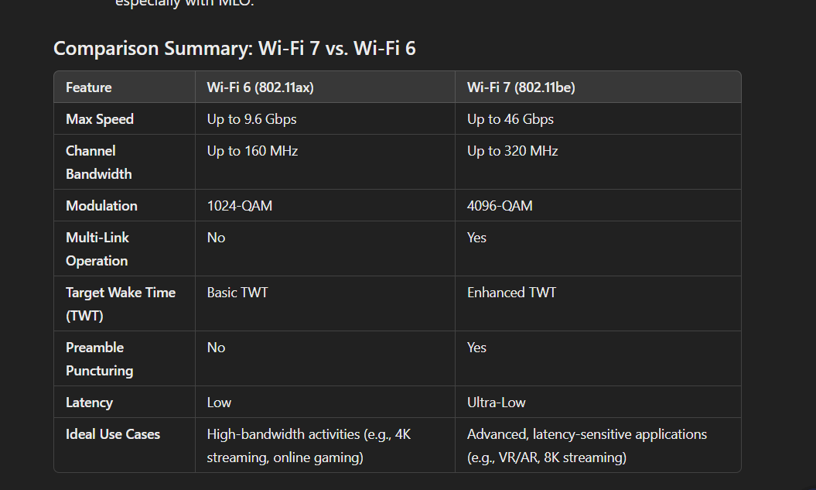
Figure : Comparison Table of Wi-Fi 6 and 7 Generated by ChatGPT
ChatGPT provided a descent information with Wi-Fi 7 and a simple comparison to Wi-Fi 6 and almost all of it was already covered in the paper, except for the TWT. But it did lack more detailed features notable in Wi-Fi 7 such as HARQ and the MIMO. Additionally, it only provided a brief explanation for every feature.
The ChatGPT response provided a compact overview of Wi-Fi 6 and 7 but still reflected what was discussed in the RRL. This is helpful when one wants to simply know the surface-level differences of each Wi-Fi technology. The depth and completeness of ChatGPT’s response highly depends on the user prompt. Vague prompts only guarantee surface-level answers.
Through the RRL process, the researchers were able to extract information exploratively, which means insights were gathered from a variety of sources, such as academic papers, technical reports, and comparative analyses. Answers were provided to questions that were not asked.
The RRL facilitated a systematic examination of key features like Orthogonal Frequency Division Multiple Access (OFDMA), Multi-User MIMO (MU-MIMO), and BSS Coloring for Wi-Fi 6, as well as Multi-Link Operation (MLO), enhanced modulation techniques, and Multi-AP Coordination for Wi-Fi 7. This approach guaranteed in-depth understanding of these technologies, especially those of PHY and MAC protocols. Moreover, even if the research began with the general objective of comparing Wi-Fi developments and their interference mitigation strategies, the RRL also enumerated their practical implications, such as the processes and theories behind throughput improvements and latency reduction.

Conclusion
By synthesizing the generous information from various sources, we find that Wi-Fi 6 introduced key features such as Orthogonal Frequency Division Multiple Access (OFDMA), Multi-User MIMO (MU-MIMO), and Basic Service Set (BSS) Coloring to improve efficiency and reliability in dense environments. Meanwhile, Wi-Fi 7 built upon these innovations by adding greater channel bandwidth, advanced modulation techniques, and technologies like Multi-Link Operation (MLO) and Multi-AP Coordination, enabling much higher throughput and lower latency. The enhancements addressed the need for high-speed, low-latency networks to support AR and VR.
At the PHY layer, Wi-Fi 6 introduced 1024-QAM modulation, allowing a 25% increase in data rates compared to Wi-Fi 5's 256-QAM. Wi-Fi 7 takes this further with 4096-QAM, improving data rates by an additional 20%. Wi-Fi 6 expanded channel bandwidth to 160 MHz, while Wi-Fi 7 doubles this to 320 MHz, enabling significantly faster data transmission. The introduction of MLO in Wi-Fi 7 allows simultaneous use of multiple frequency bands, drastically improving throughput and reducing latency compared to the single-band operation of earlier technologies. These advancements not only enhance speed but also provide better interference mitigation by dynamically utilizing available spectrum.
At the MAC layer, Wi-Fi 6 expanded MU-MIMO capabilities, enabling simultaneous uplink and downlink connections for up to eight devices, compared to Wi-Fi 5’s downlink-only support for four devices. Wi-Fi 7 doubles this capacity to 16 users and introduces enhanced features like Hybrid Automatic Repeat Request (HARQ), which improves error correction efficiency by combining retransmitted and stored data. BSS Coloring, introduced in Wi-Fi 6, remains a vital feature in Wi-Fi 7 for distinguishing overlapping networks and reducing contention in dense environments. Multi-AP Coordination in Wi-Fi 7 further optimizes channel use and improves overall network performance in areas with multiple access points.
Interference mitigation strategies have also evolved significantly. OFDM, first used in Wi-Fi 5, minimized frequency overlap by dividing signals into orthogonal subcarriers. Wi-Fi 6 improved this with OFDMA, allowing simultaneous resource allocation for multiple devices, and Wi-Fi 7 enhanced it further with MLO for multi-band operation. Beamforming, another critical strategy, first introduced in Wi-Fi 5, became more refined in Wi-Fi 6 and 7, with increased precision and integration with multi-user technologies. Time-sensitive networking (TSN), prioritized in Wi-Fi 6 and Wi-Fi 7, ensures real-time data delivery for latency-critical applications like IoT, gaming, and video conferencing.

References

[1] | Μ. (. M. &. M. B. Μπαλκώνης, "Wi-Fi Evolution: Beyond Wi-Fi 6," ProQuest Dissertations & Theses, Piraeus, 2021.
[2] | C. F. X. H. X. W. X. Y. L. H. R. L. Y. G. Y. Deng, "IEEE 802.11be Wi-Fi 7: New Challenges and Opportunities," IEEE Communications surveys and tutorials, 2020-01, vol. Vol.22 (4), pp. p.2136-2166, 2020.
[3] | A. Jeknić and E. Kočan, "Multi-Link Operation for Performance Improvement in Wi-Fi 7 Networks," in 2024 28th International Conference on Information Technology (IT), 2024.
[4] | M. Alabi, "The Evolution of Wi-Fi Standards: From Wi-Fi 6 to Wi- Fi 7," 2023.
[5] | K. Abdullah, "Interference mitigation techniques for wireless OFDM," School of Engineering, RMIT University. Thesis, 30 October 2024.
[6] | H. Arra ̃no and C. Azurdia-Meza, "OFDM: Today and in the Future of Next Generation Wireless Communications," 35th IEEE Convencion de Estudiantes de Centroamerica (CONESCAPAN 2016), September 2016.
[7] | A. Rahman, W. Hoh, S. Zakaria and N. Bakar, "IoT Wireless Protocol with 802.11AH: A Study of Interference Mitigation Techniques," Proceedings of the 2nd International Conference on Emerging Technologies and Intelligent Systems, 9 February 2023.
[8] | N. Su and Q. Zhu, "Power Control and Channel Allocation Algorithm for Energy Harvesting D2D Communications," Algorithms, vol. 12, no. 5, 2019.
[9] | E. Tokhirov, R. Aliev, I. Tanaino and T. Dzholdosheva, "Analysis of the differences between Wi-Fi 6 and Wi-Fi 5," E3S Web of Conferences, vol. 402, no. No issue number, pp. 3020-, 2023.
[10] | E. Khorov, I. Levitsky and I. F. Akyildiz, "Current Status and Directions of IEEE 802.11be, the Future Wi-Fi 7," IEEE Communications Surveys & Tutorials, vol. Volume: 22, no. 4, pp. 2136 - 2166, 2020.
[11] | t. Oyedare, V. Shah, D. Jakubisin and J. Reed, "Interference Suppression Using Deep Learning: Current Approaches and Open Challenges," IEEE Access, 21 June 2022.
[12] | J. K. N. a. P. N. T. Pulkkinen, "Understanding WiFi Cross-Technology Interference Detection in the Real World," 2020 IEEE 40th International Conference on Distributed Computing Systems (ICDCS), 23 February 2021.

